MULUNGUSHI UNIVERSITY
ICT 371 ASSIGNMENT
FRANSCINE MUKUPA
202405321
SCENARIO 1:
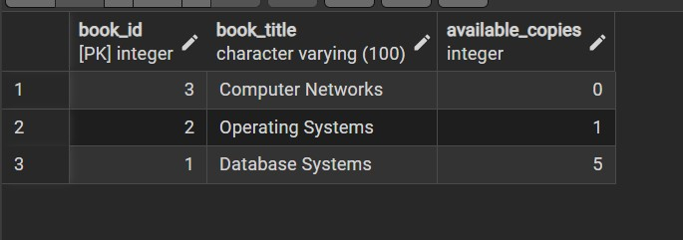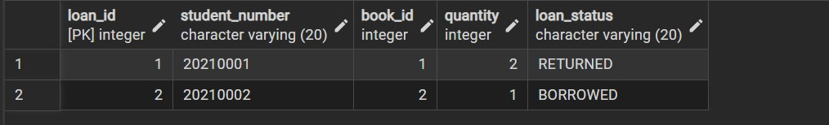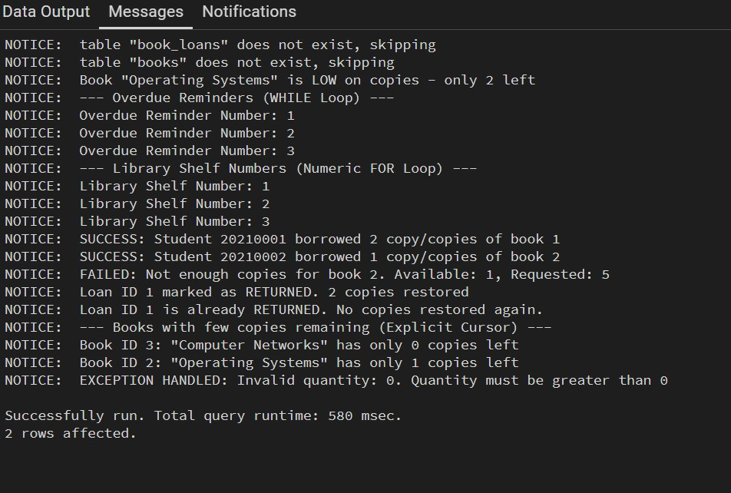
SCENARIO 2:
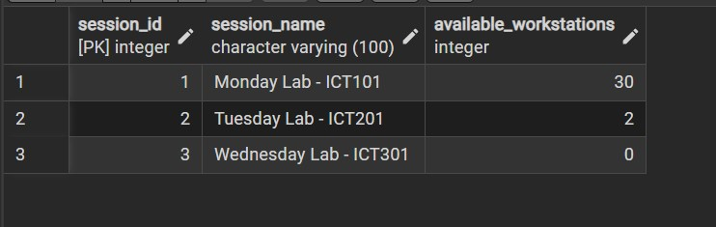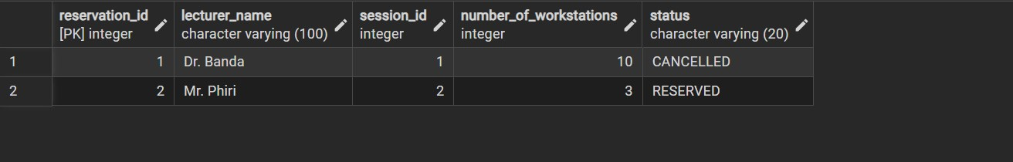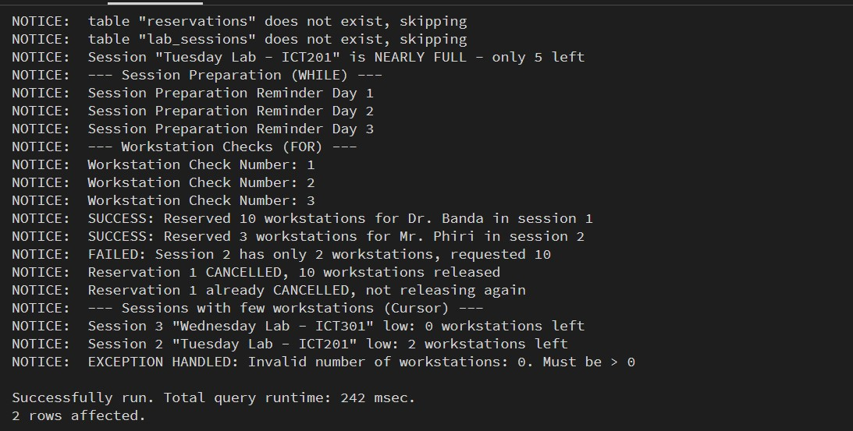
SCENARIO 3:
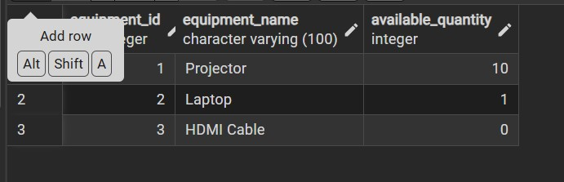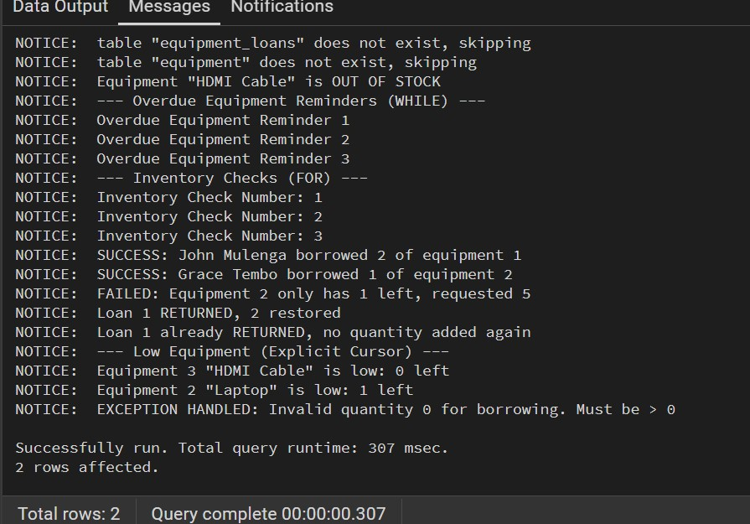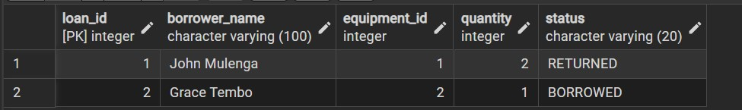
SCENARIO 4:
